Functional Requirements
4.0
Case Reference(s):
Number | Title
55498 | Buddies for 4.0

Revision History:
Revision Date | Version | Summary of Changes | Author
1/08/07 | 1.0 | Initial Version | Connie
2/26/07 | 1.1 | Updating Buddy requirements to current functionality and changes requested in 4.0 requirements meeting | Connie
3/10/07 | 1.2 | Revised to reflect requirement changes from Jay and from SME group:  - Do not need buddy tab on user screens  - Need option to remove all buddy relationships for a user  - System shall allow ability to set buddies for multiple steps  - Change user interface to be more intuitive but not grid view | Connie

Current Situation: This case was originally submitted to cover the Buddy report functionality. However, after discussions with the SME group, it has been expanded to include all Buddy functionality.

Requested Change(s): This case has been expanded to incorporate the original buddy requirements, as well as several changes and enhancements including:
Add new permissions for viewing and managing buddy relationships
Adding the ability to set up a group as buddies for all workflows / steps on the group members screen
The buddy report can be requested at the workflow root, flow or step level and will display each workflow / step on a separate page or section.
The buddy screen will be revised to be displayed in a more user friendly interface.

SME’s: Jay, Mike F, Eric Rowe, Alex Grieco, Greg McCoy, Chris Peters, Don Elias
QA Reviewer:

Requirements:
- The system shall have the ability to make users and groups buddies with other users and groups.
  - The system shall have the option to make buddy relationships Uni-directional (one-way).
  - The system shall have the option to make buddy relationships Bi-directional (reciprocal)
    - The system shall default the buddy relationships to Bi-directional.
      - The system shall have the option to change to Uni-directional when creating buddy relationships.
  - The system shall have the ability to assign buddies at the Workflow Step level
  - .The ability to assign buddies at the Workflow and root level should be removed from the system.
[BR – The SME group does not see value in assigning buddies at the workflow level.]
  - The system shall have the ability to make the following user object buddy relationships.
    - User – User Buddy Relationship
    - Group – User Buddy Relationship
    - Group – Group Buddy Relationship
  - The system shall include a new user in an existing group buddy relationship automatically, when a user is added to the group.
  - The system shall provide the ability to make all members of a group buddies with each other.
    - The system shall include a checkbox on the Group Members tab of the group in the User Management section of IEMC to make members of the group buddies (similar to 3.5 functionality).
[BR- This provides a very convenient way for the end user to make group members buddies for all flows and steps. This functionality needs to be retained since we provided this in 3.5.]
      - The label for the checkbox shall be ‘Members are Buddies’.
      - The members of the group shall be treated as buddies for all workflow steps for which the group has rights.
- The system shall provide new workflow permissions for Viewing and Changing Buddy relationships.
[BR – The administrator who is responsible for maintaining buddies may not be the same person who maintains workflow permissions.]
  - The View Buddy Relationships permission shall allow the user to view the Buddy relationships for the assigned workflow / steps.
    - The View Buddy Relationships permission will allow the user to generate and view the Buddy Report.
  - The Change Buddy Relationships permission shall allow the user to manage Buddy relationships for the assigned workflow / steps.
    - The Change Buddy Relationships permission will allow the user to add, remove, and change Buddy relationships.
    - The Change Buddy Relationships permission will allow the user to generate and view the Buddy Report.
  - If the View Buddy Relationship permission is granted to a user, group, or role at the workflow root level, the user will have rights to view buddies for all workflows and steps.
  - If the View Buddy Relationship permission is granted to a user, group, or role for a workflow, the user will have rights to view buddies for all steps in that workflow.
  - If the View Buddy Relationship permission is granted to a user, group, or role for a workflow step, the user will have rights to view buddies for the step.
  - If the Change Buddy Relationship permission is granted to a user, group, or role at the workflow root level, the user will have rights to manage buddies for all workflows and steps.
  - If the Change Buddy Relationship permission is granted to a user, group, or role for a workflow, the user will have rights to mange buddies for all steps in that workflow.
  - If the Change Buddy Relationship permission is granted to a user, group, or role for a workflow step, the user will have rights to manage buddies for the step.

- The Buddies user interface in the Workflow Settings of IEMC should be revised to be easier and more intuitive for the user (see screen print below).
  - The Buddies tab shall display two selection trees for selecting the user / group and the corresponding user / group to be assigned as a buddy.
    - The selection tree shall list all users and groups that have rights to work tasks in all selected workflow step(s).
      - If using Integrated Security, the tree shall include AD users and groups that have been granted rights to work the step.
      - Groups that have rights to the step shall expand in the tree to list all users included in the group to allow buddy assignments for the users.
    - The user shall have the ability to select one or more users and groups from the left selection tree to assign buddies to.
    - The user shall have the ability to select one or more users / groups from the right selection tree to be assigned as buddies for the selected user / group on the left.
    - The Make Buddies button shall be disabled until one or more selections of users and groups in the user tree and in the buddy tree are selected.
      - When the Make Buddies button is pressed, the system shall edit the selections and add valid buddy relationships to the Buddy Relationship grid.
        - If the selected users / groups are already designated as buddies, the following error message shall display ‘Selected User(s) / Group(s) are already designated as buddies.’
        - If the user has selected multiple users or groups to be made as buddies, and some of the selections are already existing buddies, the system shall add the new valid buddy relationships that have been selected.
    - The screen shall allow user to specify whether the buddy relationship should be ‘Bi-directional’ or ‘Uni-directional’.
      - The system shall default to the ‘Bi-directional’ buddy relationship.
  - The Buddy Relationship grid shall display all buddy relationships for the selected step(s).
    - When the screen is initially displayed, all existing buddy relationships for the selected step(s) shall be populated in the Buddy Relationship grid.
    - Bi-directional buddy relationships shall be listed twice in the buddy grid. If Bart and Catty are Bi-directional buddies, the following rows will be shown in the grid:
[BR – This will make it easier for the users to filter and view all buddy relationships for a particular user or group.]

User / Group | Relationship | Buddy
Bart | Bi-directional | Catty
Catty | Bi-directional | Bart

    - The grid shall include filters to allow the user to filter each column by a selected value.
[BR The filters will allow the user to easily identify the buddy relationships for a certain user or group without having to scroll through the entire list.]
    - The grid shall allow the user to sort the buddy list by clicking the column headings.

  - The Buddy grid shall provide the ability for a user to remove a buddy relationship.
    - The system shall display a context menu item ‘Remove Buddy Relationship’ which shall be displayed if the user selects one or more rows in the grid and right clicks.
    - If selected, the Remove Buddy Relationship option will delete the selected buddy relationships for the step.
    - If one side of a bi-directional buddy relationship is deleted, the corresponding buddy relationship shall be deleted as well.
  - If multiple workflow steps are selected, the buddies tab shall display buddy relationships that are assigned for all selected steps.
    - Only users with rights for all selected steps will be displayed in the user selection trees on the screen.
    - The grid shall display the appropriate buddy relationships (Bi-directional, Uni-directional) for users that are designated as buddies for all selected steps.
    - Any buddy relationships added or removed shall be applied to all selected workflow steps.
  - If the user presses the OK button, all changes made on the Buddy Relationship tab (as well as any changes made on the Security tab) shall be saved to the database and the Step properties screen shall close.
  - If the user presses the Apply button, all changes made on the Buddy Relationship tab (as well as any changes made on the Security tab) shall be saved to the database without closing the screen.
  - If the user presses the Cancel button, the system shall close the screen without saving any changes made in the Security or Buddies tabs.
  - The Properties screen shall allow the user to expand the screen.
    - If the screen is expanded, the Buddy Relationship grid shall expand with the screen to allow the user to view to view all applicable buddy relationships for the step(s).

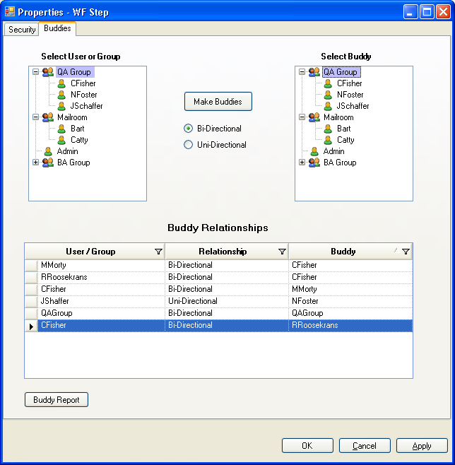

- The system shall provide a report for displaying Buddy relationships.
  - The system shall have the ability to generate a report showing all buddy relationships.
    - The Buddy report shall display all Uni-directional and Bi-directional buddy relationships.
    - The Buddy report shall include group-group, group-user, user-user and user-group buddy relationships.
  - If the report is requested at the workflow root level, the report shall include all workflows and steps.
  - If the report is requested at the workflow level, the report shall include all steps in the selected workflow.
  - If the report is requested at the workflow step level, it shall include only the selected step.
  - The buddy report shall display each workflow / step on a separate page or section of the report.
    - Each page and section of the report shall display the current Flow name and Step name.
    - The report shall display the text ‘Uni-directional’ and ‘Bi-directional’ to indicate the buddy relationship.
    - If no buddy relationship exists, the space on the report for that relationship shall be blank.
- The system shall provide a new tab on the User Management properties screen to display Buddy Options at the user object level.
  - The system shall provide a report at the user level to allow the user to view all buddy relationships for the selected user or group.
    - When selected, the system shall display a report which displays all buddy relationships for the selected user or group for all flows and steps.
    - The workflows and steps should be listed down the left side of the report.
    - The Users and groups who are buddies with the selected user shall be listed across the top of the report.
    - The report shall display the text ‘Uni-directional’ and ‘Bi-directional’ to indicate the type of buddy relationship.
    - If no buddy relationship exists, the space on the report for that relationship shall be blank.
    - If multiple users or groups are selected, the report shall be run for all of the user selections.
      - The buddy relationships for each selected user and group will be displayed on a separate page or section of the buddy report.
  - The system shall provide a new option in the IEMC User Management properties screen to allow the ability to remove all buddy relationships for the selected user(s) or group(s).
[BR – This will prevent administrator from having to go to each workflow step that the user is assigned buddy relationships for and deleting the buddy relationships one by one.]
    - The ‘Remove All Buddy Relationships’ option shall be displayed on the on the Buddy Options tab on the User management properties screen.
    - When selected, the system shall ask user to confirm the action by displaying the following message: “All Buddy Relationships for selected user(s) and group(s) will be removed. Are you sure?”.
    - If User selects ‘Yes’, then the system shall delete all buddy relationships from the system for the selected users and groups.

Definitions:
Buddy = user who can access another user’s To Do list for specified flow/step/root
Uni-directional = one-way buddies. User A is a Uni-directional buddy with User B, therefore User A can access User B’s To Do list
Bi-directional = reciprocal buddies. User A and User B have access to each others’ To Do lists

Considerations:
Jay Calcagni’s feedback was that the grid view of buddies in 3.x is a problem because the size of the grid becomes unmanageable when there are a large number of users. He suggested the screen design shown above. However, Guido Glovers has concerns that we maintain the consistency of the system and use a grid view similar to the way the security screens are implemented in 4.0.

